MEMORANDUM OF UNDERSTANDING (MOU)
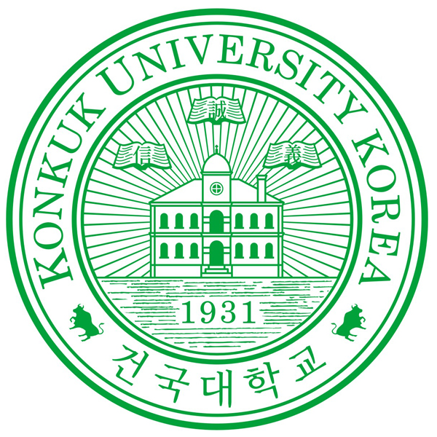
BETWEEN
Partner
University
Logo
KONKUK UNIVERSITY, SEOUL, REPUBLIC OF KOREA
AND
(UNIVERSITY NAME), (CITY, STATE, COUNTRY)

Konkuk University and (University Name) agree to implement this memorandum of understanding.

This agreement is based on the principle of reciprocity and expresses the interest of both parties in exchanging scholars, students, academic information and materials in the belief that the research and educational process at both the institutions will be enhanced and that mutual understanding between their respective scholars and students will be increased by the establishment of such exchange programs.

- The universities agree to encourage the development of the following exchange programs based on their respective academic and educational needs:

  - Exchange of faculty
  - Exchange of students (Undergraduate and Graduate)
  - Joint supervision of Master and Ph.D. students
  - Exchange of academic information and materials
  - Exchange of periodicals and other publications
  - Organization of joint research programs
  - Organization of joint conferences
  - Organization of other academic exchanges agreeable to both universities

- The parties recognize that the implementation of any exchange program will depend upon the academic interests and expertise of individual faculty members and upon the availability of financial resources. Accordingly, the implementation of each exchange program based on this agreement shall be separately negotiated and determined by both universities.

- This agreement is not intended to be a legally binding document. It is meant to describe the nature and to suggest the guidelines of the cooperation described above. Nothing therefore shall diminish the full autonomy of either institution, nor will any constraints be imposed by either upon the other in carrying out the agreement.

- The agreement shall become effective on the day representatives of both universities affix their signatures and seals, will be in force for a period of 5 years. As long as one party does not give six months notice terminating this agreement, it shall automatically be renewed. It is also understood that either institution may terminate the agreement at any time, although is assumed that such action would only be taken after mutual consultation in order to avoid any possible inconvenience to the other institution.

- For Konkuk University, Vice President for International Affairs and for (University Name), (liaison officer’s position) shall serve as liaison officers for this agreement.

Konkuk University, Hanoi University of Technology, |  | (University Name),
_________________________ |  | _________________________
Dr. Young Jae Jeon Hoang Ba Chu, Ph.D. |  | (Name)
President Rector |  | (Position)
Date: |  | Date:

__________________________ |  |  | _________________________
Dr. Donghyuck Lee Hoang Ba Chu, Ph.D. |  |  | (Name)
Vice President for International Affairs Rector |  |  | (Position)
Date: |  |  | Date:

